EVALUATION REPORT
Residential Behavioral Program Evaluation of Program Year 1
New Jersey Natural Gas

Date: January 31, 2023

Table of contents
Abstract ii
Executive Summary iii
1 INTRODUCTION 1
1.1 Background 1
1.2 Program design and implementation 1
1.3 Evaluation objectives 1
2 APPROACH AND METHODS 3
3 ANALYSIS AND KEY FINDINGS 4
3.1 Program processes and implementation 4
3.2 Program participation 6
3.3 Data quality summary 10
4 FINDINGS AND RECOMMENDATIONS 12
5 Program Comparison 13
APPENDIX A. PROGRAM MANAGER IN-DEPTH INTERVIEW GUIDE 14
APPENDIX B. PROGRAM IMPLEMENTER IN-DEPTH INTERVIEW GUIDE 16

List of figures

Figure 3-1. Reporting delivery frequency 4
Figure 3-2. Example eHER 4
Figure 3-3. Example of cross-promotion 5
Figure 3-4. High usage alert sample 6
Figure 3-5. Attrition of Opower waves 9
Figure 3-6. Attrition of Uplight waves 9

List of tables

Table 2-1. Data sources 3
Table 3-1. Wave start and end dates 7
Table 3-2. Total HERs and eHERs sent (2021 - 20222) 7
Table 3-3. Challenge alerts and HUAs by report type for treatment households (2021 - 2022) 8
Table 3-4. Challenge alerts and HUAs for eHER treatment households (2021 - 2022) 8
Table 3-5. Attrition by wave 10
Table 3-6. Participation information for participants in multiple waves 11
Table 3-7. Participation information for control participants that received reports 11
Table 5-1. Comparison to other gas programs 13

Abstract
This report provides the results of the impact and process evaluations of New Jersey Natural Gas's (NJNG) Residential Behavioral Program for the period beginning July 1, 2021, and ending June 30, 2022 (Program Year 1, or PY1).
The primary objectives for the first year of the impact evaluation were to assess program evaluability and summarize program participation. The primary objectives of the preliminary process evaluation were to document the program's goals, theory of change, and key activities; understand program administration and implementation processes to identify potential opportunities for improvement and greater customer participation; and review Reports, High Usage Alert (HUA) e-mails, challenge e-mails, and other program documentation and outreach materials.

Findings

Process evaluation:
Program deployment and reporting processes are streamlined and effective. Treatment and control groups are set up for each wave based on 13 months of utility data prior to wave launch. Customers with e-mails received both eHERs and paper HERs, otherwise customers received only paper HERs. Each customer may receive eHERs and/or HERs, periodic weekly challenges via email, and HUAs when appropriate.

Impact evaluation:
- The programs have retained sufficient data to evaluate all waves of the Behavioral program in Year 2 of the evaluation.
- Out of the 430,244 participant list records and 26,798,381 rows of billing data reviewed, less than 0.01 percent of records had an identified data quality issue. While these issues impact only a small share of program records, they could indicate minor issues in the program data quality checks.

Recommendations

Process evaluation:
- Investigate strategies to gather more accurate e-mail addresses for eHERs customers, especially if eHERs prove to generate more savings than paper HERs. NJNG's new Customer Resource Management (CRM) system contributes to improving contact information by allowing easier additions and updates to email and mailing addresses.
- Track customers across different programs (i.e., cross-reference tracking data from other NJNG programs to see if Behavioral program participants engaged in other utility offerings for efficiency). NJNG is loading historic program information into the new CRM system as well, which will improve their ability to track customer participation in different programs.

Impact evaluation:
- Investigate whether there may be room to increase the share of HER treatment households receiving eHERs (57% overall, currently).
- Review whether the customers with provided billing data that are not in the participation list are actually HER participants and update the participant list if necessary (see Section 3.3.1).
- Review and adjust the handful of records (5 households) where participants were assigned to multiple waves (see Section 3.3.2).
- Investigate whether two control group participants are receiving HERs or if there was an error in the participation list (see Section 3.3.3).

Executive Summary
This report provides the results of the impact and process evaluations of New Jersey Natural Gas's (NJNG) Residential Behavioral Program for the period beginning July 1, 2021, and ending June 30, 2022 (Program Year 1, or PY1). The Residential Behavioral program educates and provides customers with granular, easy-to-understand information about their energy use and that of their neighbors and suggests actionable steps to generate awareness and motivate customers to produce energy savings through behavioral changes and engagement with other NJNG energy-efficiency programs.
The primary objectives for the first year of the impact evaluation were to assess program evaluability and summarize program participation. The primary objectives of the preliminary process evaluation were to document the program's goals, theory of change, and key activities; understand program administration and implementation processes to identify potential opportunities for improvement and greater customer participation; and review Reports, High Usage Alert (HUA) e-mails, challenge e-mails, and other program documentation and outreach materials.

Methods
The DNV evaluation team reviewed participation data and historical and current billing data for Behavioral program participants. The team also conducted program staff interviews to better understand and document program implementation processes. DNV documented the program staff's understanding of the program goals and objectives and learned how the staff perceives the customer experiences, successes, and challenges.

Findings and recommendations

Process evaluation:
- Program deployment and reporting processes are streamlined and effective. Treatment and control groups are set up for each wave based on 13 months of utility data prior to wave launch. Customers with e-mails received both eHERs and paper HERs, otherwise customers received only paper HERs. Each customer may receive eHERs and/or HERs, periodic weekly challenges via email, and HUAs when appropriate.
- The contractor indicated that the program has been run successfully and has been reaching energy savings goals consistently. However, both the implementer and program staff indicated several challenges.
- Recommendation: Investigate strategies to gather more accurate e-mail addresses for eHERs customers if eHERs prove to generate more savings than paper HERs. NJNG's new Customer Resource Management (CRM) system contributes to improving contact information by allowing easier additions and updates to email and mailing addresses.
- Recommendation: Track customers across different programs (i.e., cross-reference tracking data from other NJNG programs to see if Behavioral program participants engaged in other utility offerings for efficiency). NJNG is loading historic program information into the new CRM system as well, which will improve their ability to track customer participation in different programs.

Impact evaluation:
- The programs have retained sufficient data to evaluate all waves of the Behavioral program in Year 2 of the evaluation.
- Recommendation: Investigate whether there may be room to increase the share of HER treatment households receiving eHERs (57% overall, currently).
- Out of the 430,244 participant list records and 26,798,381 rows of billing data reviewed, less than 0.01 percent of records had an identified data quality issue. While these issues impact only a small share of program records, they could indicate minor issues in the program data quality checks:
- Recommendation: Review whether the customers with provided billing data that are not in the participation list are actually HER participants and update the participant list if necessary (see Section 3.3.1).
- Recommendation: Review and adjust the handful of records (5 households) where participants were assigned to multiple waves (see Section 3.3.2).
- Recommendation: Investigate whether two control group participants are receiving HERs or if there was an error in the participation list (see Section 3.3.3).

INTRODUCTION
This report provides the results of the impact and process evaluations of New Jersey Natural Gas's (NJNG) Residential Behavioral Program for the period beginning July 1, 2021, and ending June 30, 2022 (Program Year 1, or PY1).

Background
The Residential Behavioral program educates and provides customers with granular, easy-to-understand information about their energy use and that of similar customers in their area and suggests actionable steps to generate awareness and motivate customers to produce energy savings through behavioral changes and engagement with other NJNG energy-efficiency programs.
The program's primary purpose is to reduce energy consumption by motivating no-cost and low-cost energy conservation actions and self-installing energy-saving measures. This is achieved primarily through the use of Home Energy Reports (HERs) and electronic Home Energy Reports (eHERs) ("Reports") that include information about energy consumption, a comparison to the energy consumption of similar customers, and customized tips for saving energy. While most HERs are delivered through the mail in the fall and winter (September to February), participants may also receive eHERs through e-mail (eHERs) if they have provided their e-mail address to NJNG. NJNG also sends participants who have provided their e-mail address High Usage Alerts (HUAs) when the weather is forecast to be particularly cold. Additionally, participants who complete a residential online assessment may opt-in to receive weekly energy challenge e-mails, which provide energy savings tips and information. NJNG offers sweepstakes promotions to encourage participation in the energy challenges during the fall and winter.

Program design and implementation
NJNG uses Uplight, a third-party contractor (referred to as an implementer in this report) to provide the services under this program. The vendor identifies and distributes the Reports to residential customers at no charge based on an opt-out program design. The program primarily targets single-family homes. These customers receive customized low- to no-cost energy-saving tips and other program opportunities available to them, including income-qualified programs for presumed income-qualified recipients. The Reports offer tailored recommendations for customers to reduce their energy consumption.
NJNG's Behavioral program was launched in 2011. It includes seven waves that were started at different times and are designed to target specific customer segments. Within each wave, the customers were randomly assigned to either the treatment or the control group, using a randomized control trial (RCT) design. The treatment group receives the Report and other treatment approaches (high bill alerts, energy challenges), while the control group does not. This randomization means that, except for receiving Reports, the treatment and control group customers are alike. The RCT framework is the most effective way to establish a causal relationship between a treatment and its effect and provides unbiased estimates of the Report treatment effect.

Evaluation objectives
For the Behavioral Program, the primary objectives for the first year of the impact evaluation were to:
- Assess program evaluability.
- Summarize program participation.
The primary objectives of the preliminary process evaluation were to:
- Document the program's goals, theory of change, and key activities.
- Understand program administration and implementation processes to identify potential opportunities for improvement and greater customer participation.
- Review Reports, High Usage Alert (HUA) e-mails, challenge e-mails, and other program documentation and outreach materials.

APPROACH AND METHODS
The DNV evaluation team reviewed participation data and historical and current billing data for Behavioral program participants. The team also conducted program staff interviews to better understand and document program implementation processes. DNV documented the program staff's understanding of the program goals and objectives and learned how the staff perceives the customer experiences, successes, and challenges. Table 2-1 provides greater detail on the content of each data source.
Table 2-1. Data sources
Data Type | Source | Key Fields Included | Data Use
Participant List | Uplight | Customer account numbers  Wave  Treatment / control  HER and eHER sent dates  Challenge enrollment  Opt-out dates  Account inactivity date | Identifies treatment and control households, as well as other aspects of household participation in the Behavioral program
Monthly Billing Data | Uplight | Customer account numbers  Account inactivity date  Bill start- and end- dates  Bill duration  Usage | Provides information about how participants use gas and whether their usage changes following program enrollment
Legacy Billing Data | Uplight | Customer account numbers  Account inactivity date  Bill start- and end- dates  Bill duration  Usage | Provides information about gas consumption and whether treatment group usage changes following program enrollment
Interviews | Program Staff | N/A | Gain an understanding of where the actual day-to-day program implementation diverges from the intended program implementation

ANALYSIS AND KEY FINDINGS

Program processes and implementation
Program deployment and reporting processes are streamlined and effective. Treatment and control groups are set up for each wave based on 13 months of utility data prior to wave launch. Customers with e-mails received both eHERs and paper HERs, otherwise customers received only paper HERs. As shown in Figure 3-1, each customer may receive eHERs and/or HERs, periodic weekly challenges via email, and HUAs when appropriate.
Figure 3-1. Reporting delivery frequency
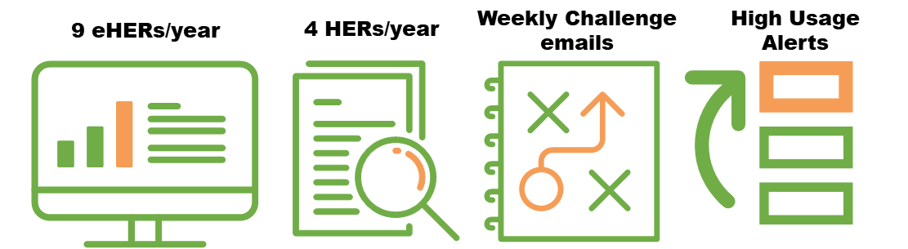
Initial waves had messaging referencing comparions to neighbors' energy usage. After customer feedback was received, the approach transitioned to messaging referencing comparisons to “similar homes”. Waves based on certain customer segments had specific messaging appropriate for the group (e.g., for low-income waves, the reports included low-cost energy-saving tips and information on energy assistance programs). Figure 3-2 shows an example of an eHER showing a similar home comparison view.
Figure 3-2. Example eHER
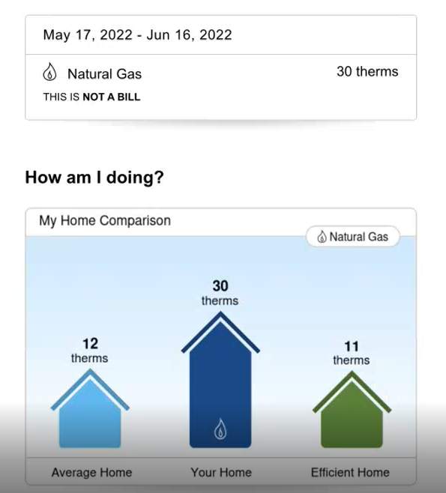
The reports also include resources like energy-saving tips and connections to other NJNG programs that help customers maximize their energy savings. Figure 3-3 below shows an example of how an eHER cross-promotes other energy efficiency programs.
Figure 3-3. Example of cross-promotion
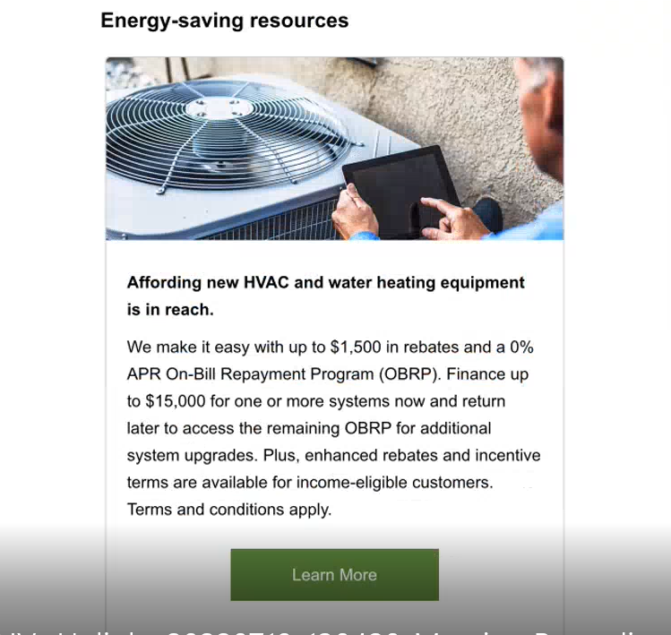
As the program has progressed over the years, the implementer has added strategies like weekly challenges where customers can opt into suggested energy-saving actions. Additionally, the program sends high-usage alerts based on projected consumption and forecasted weather. The high usage alerts go to the treatment group. Figure 3-4 shows an example of an HUA.
Figure 3-4. High usage alert sample
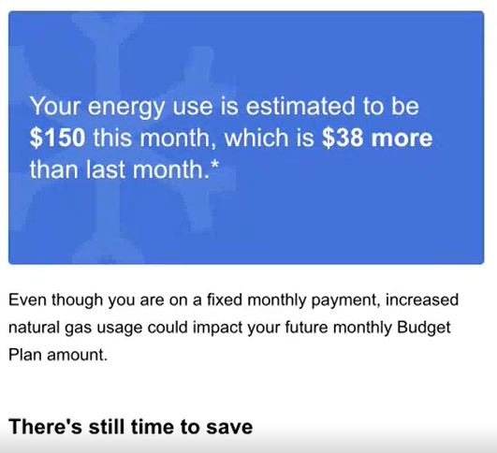
The implementation contractor provides a monthly savings report to NJNG and tracks click-throughs for the eHERs and challenge participation. Open rates for eHERs in 2022 averaged over 50%, while click rates averaged around 1%. Weekly challenge e-mail open rates in 2022 averaged just under 50%, and click rates averaged just under 3%.
The contractor indicated that the program has been run successfully and has been reaching energy savings goals consistently. However, both the implementer and program staff indicated several challenges:
- As the treatment group expands, the program might be at risk of maxing out the number of customers in the treatment group. The program could be approaching saturation.
- Additionally, as customers continue to receive HERs, it is increasingly difficult to ensure engagement and provide suggestions for energy-saving measures. Many customers only replace big-ticket items like boilers infrequently, and other suggested energy-saving tips based on behavior changes provide a lower volume of savings.
- Having accurate e-mail addresses for eHERs recipients can be a challenge.

Program participation
The seven waves of the Behavioral program were launched between March 2011 and October 2020. Wave start dates can be found in Table 3-1. The first five waves were launched by Opower (Oracle), while the two most recent waves were launched by Uplight (previously Tendril). All waves continue to be actively treated and are now administered by Uplight. Some waves are designed to target specific customer segments. These waves are drawn from specified customer segments, such as low-income customers, and the treatment and control groups are randomly assigned following the RCT design. Wave 3 specifically targeted low-income customers, while waves 4 and 5 targeted customers who had participated in NJNG's SAVEGREEN HVAC incentive program in the past but still had opportunities for other measures, such as seal-up and insulation. Wave 6 is the largest wave, accounting for 53% of HER participants.
Table 3-1. Wave start and end dates
Wave | Wave Name | Start Date | Starting Treatment Group Participants | Starting Control Group Participants
Wave 1 | njng_her_201103_g | March 2011 | 19,369 | 19,330
Wave 2 | njng_her_201301_g | January 2013 | 15,535 | 12,879
Wave 3 | njng_her_201509_g_lowincome | September 2015 | 9,429 | 9,455
Wave 4 | njng_her_201509_g_savegreen | September 2015 | 19,065 | 10,006
Wave 5 | njng_her_201609_g_savegreen | September 2016 | 9,851 | 9,873
Wave 6 | njng_her_tendril_201902 | February 2019 | 204,452 | 20,000
Wave 7 | njng_her_uplight_202009 | October 2020 | 46,000 | 25,000
Table 3-2 presents the breakdown of report types by wave for treatment households with active accounts between January 2021 and June 2022. Unless they have opted out, all treatment households continue to receive paper reports. Participants with known e-mail addresses receive both electronic Home Energy Reports (eHERs) and paper HERs unless a customer has specifically requested to opt-out of the print version in favor of the eHER. Overall, 57% of treatment households received eHERs. The most recent wave launched, wave 7, has the highest share of treatment households with e-mail addresses provided, with 89% receiving eHERs. Wave 3, which targets low-income customers, has the lowest share of participants with provided e-mail addresses, with 44% of treatment households receiving eHERs. For all waves, a large share of treatment households receive paper Reports only. A small subset of the thousands of treatment households do not receive any Reports. For most of these households, it is not clear why they are not receiving Reports. Only 12 of these households have opted out of receiving HERs. Households who have opted out of receiving HERs are still considered part of the treatment group to maintain the integrity of the randomized control trial design, as control households do not have the option to opt-out.
Table 3-2. Total HERs and eHERs sent (2021 - 20222)
Wave | Treatment Households | Received eHER | Received Paper HER Only | Didn't Receive a Report
Wave 1 | 15,097 | 8,239 | 6,827 | 31
Wave 2 | 12,372 | 6,436 | 5,907 | 29
Wave 3 | 6,440 | 2,834 | 3,576 | 30
Wave 4 | 14,933 | 8,739 | 6,152 | 42
Wave 5 | 7,766 | 4,549 | 3,205 | 12
Wave 6 | 176,494 | 97,528 | 78,916 | 50
Wave 7 | 43,205 | 29,993 | 13,009 | 203
In addition to HERs and eHERs, the Behavioral program is designed to provide high usage alerts (HUAs) and challenges to those customers receiving an eHER. 79% of treatment households who receive eHERs receive HUAs, 4% of treatment households receive challenges, and 20% do not receive challenges or HUAs. HUA and challenge recipients were expected to be a subset of the eHER recipients, as both are delivered electronically via e-mail. However, a handful of participants who opted to receive paper-only reports also received challenge alerts or HUAs electronically. The households receiving paper HERs (not eHERs) and HUAs or challenges may have provided sufficient information to also send eHERs for future program years. Table 3-3 presents the breakdown of treatment households across waves that received challenges and HUAs by report type.
Table 3-3. Challenge alerts and HUAs by report type for treatment households (2021 - 2022)
Report Type | Treatment Households | Received Both Challenges and HUAs | Challenges Only | HUAs Only | Received Neither Challenges nor HUAs
eHER | 158,318 | 5,407 | 1,105 | 119,653 | 32,153
HER Only | 117,592 | 4 | 6 | 15 | 117,567
No Report* | 397 | 0 | 0 | 76 | 321
*47 of these households had opted out of receiving HERs.
Participants with known e-mail addresses can receive challenges and high usage alerts (HUAs). Table 3-4 shows the breakdown of treatment households that received eHERs and a combination of challenges and HUAs. Overall, 79% of eHER recipients also received HUAs, while only 4% received challenges. There was relatively little variation across waves within the eHER participants. Wave 7 had the lowest share of challenge participation at 3%, while wave 4 had the highest challenge participation at 5% of eHER recipients.
Table 3-4. Challenge alerts and HUAs for eHER treatment households (2021 - 2022)
Wave | Treatment Households with eHERs | Received Both Challenges and HUAs | Challenges Only | HUAs Only | Received Neither Challenges nor HUAs
Wave 1 | 8,239 | 256 | 70 | 5,873 | 2,040
Wave 2 | 6,436 | 206 | 48 | 4,790 | 1,392
Wave 3 | 2,834 | 82 | 11 | 2,046 | 695
Wave 4 | 8,739 | 359 | 71 | 6,583 | 1,726
Wave 5 | 4,549 | 178 | 36 | 3,510 | 825
Wave 6 | 97,528 | 3,643 | 711 | 75,180 | 17,994
Wave 7 | 29,993 | 683 | 158 | 21,671 | 7,481

Over time, as participants move, behavioral programs experience attrition from both the treatment and control groups. While this is a normal occurrence, it is useful to monitor the attrition rate, as it can vary depending on customer characteristics. As the number of participants decreases in a wave (attrition), it impacts total program savings. Figure 3-5 and Figure 3-6 are visual representations of the average number of active treatment participants from the beginning of the wave through the end of April 2022. Starting around 2017, the participation levels consistently fell over time. Waves 3 and 6 have the highest average year-to-year attrition (6.5% and 6.2%, respectively), while waves 1 and 2 have the lowest (3% and 3.2%, respectively). Table 3-5 shows the original sample size, the average customer in 2022, and attrition for each wave. Waves 6 and 7 have the lowest attrition, likely due to their most recent start dates. Wave 3 has the highest rate of attrition. Low-income households are more likely to be rentals, so the high attrition rate could be due to a higher relocation rate among renters.

Figure 3-5. Attrition of Opower waves
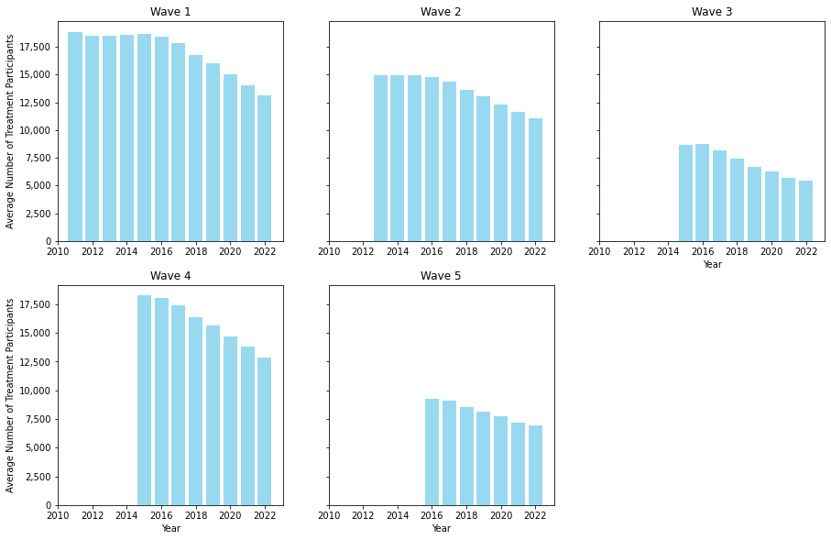
Figure 3-6. Attrition of Uplight waves
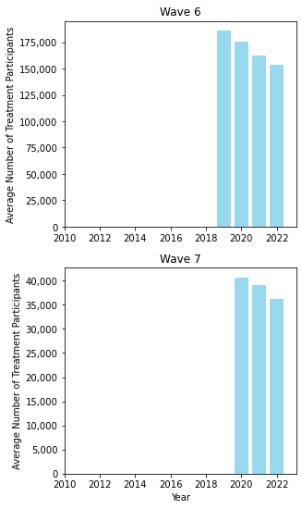
Table 3-5. Attrition by wave
Sample | Control Group Customers |  | Treatment Group Customers
 | Number | % | Number | %
Wave 1
Original Sample | 19,330 |  | 19,369
Attrition (move-outs) | 6,171 |  | 5,463
Avg Active Customers, 2022 | 13,159 | 32% | 13,907 | 28%
Wave 2
Original Sample | 12,879 |  | 15,535
Attrition (move-outs) | 3,782 |  | 4,465
Avg Active Customers, 2022 | 9,098 | 29% | 11,070 | 29%
Wave 3
Original Sample | 9,455 |  | 9,429
Attrition (move-outs) | 4,034 |  | 4,013
Avg Active Customers, 2022 | 5,421 | 43% | 5,416 | 43%
Wave 4
Original Sample | 10,006 |  | 19,065
Attrition (move-outs) | 3,245 |  | 6,177
Avg Active Customers, 2022 | 6,761 | 32% | 12,888 | 32%
Wave 5
Original Sample | 9,873 |  | 9,851
Attrition (move-outs) | 2,957 |  | 2,939
Avg Active Customers, 2022 | 6,916 | 30% | 6,912 | 30%
Wave 6
Original Sample | 20,000 |  | 204,452
Attrition (move-outs) | 5,009 |  | 51,130
Avg Active Customers, 2022 | 14,991 | 25% | 153,322 | 25%
Wave 7
Original Sample | 25,000 |  | 46,000
Attrition (move-outs) | 5,408 |  | 9,811
Avg Active Customers, 2022 | 19,592 | 22% | 36,190 | 22%

Data quality summary
As part of the data review and assessment, DNV reviewed 430,244 records in the participant list and 26,798,381 rows of billing data spanning from 2010 through 2022. Based on this data, we found that we have sufficient data to complete the full billing analysis for the next evaluation cycle. Additionally, we identified a few potential data quality issues, including:
- Missing data (Section 3.3.1)
- Participants in multiple waves (Section 3.3.2)
- Control participants who received treatment (Section 3.3.3)

Missing data
Two hundred seventy-nine (279) customers in the billing datasets had no participation data available. The billing data is from the end of 2009 to May 2022. These records may have been included accidentally, or they may have been accidentally excluded from the participant list.

Participants in multiple waves
Five participants (treatment and control) were enrolled in multiple waves. All five participants had the same report opt-out date. Additional information about each participant can be found in Table 3-6.
Table 3-6. Participation information for participants in multiple waves
Participant | Wave | Treatment / Control | HUA Enrollment Date | eHER Opt-Out Date | Paper HER Opt-Out Date | Inactive Date
Participant 1 | Wave 1 | Treatment | 10/18/2019 | 1/25/2019 | 1/25/2019
 | Wave 3 | Control
Participant 2 | Wave 1 | Treatment |  | 1/25/2019 | 1/25/2019 | 12/6/2019
 | Wave 4 | Control
Participant 3 | Wave 1 | Control | 10/18/2019 | 1/25/2019 | 1/25/2019
 | Wave 4 | Treatment
Participant 4 | Wave 1 | Control |  | 1/25/2019 | 1/25/2019
 | Wave 5 | Control
Participant 5 | Wave 1 | Control |  | 1/25/2019 | 1/25/2019 | 1/24/2020
 | Wave 5 | Control

Control group participants that received reports
Two participants in Wave 5's control group received reports. Both participants were enrolled in challenges and high bill alerts, and neither account was inactive. Additional information about each participant can be found in Table 3-7.
Table 3-7. Participation information for control participants that received reports
Participant | Wave | Paper HERs |  |  | eHERs
 |  | Date First Sent | Date Last Sent | Total Sent | Date First Sent | Date Last Sent | Total Sent
Participant 1 | Wave 5 | 9/27/2019 | 3/3/2022 | 13 | 9/27/2019 | 5/16/2022 | 25
Participant 2 | Wave 5 | 10/8/2019 | 3/11/2022 | 13 | 10/8/2019 | 5/16/2022 | 21

FINDINGS AND RECOMMENDATIONS
Process Evaluation:
- Program deployment and reporting processes are streamlined and effective. Treatment and control groups are set up for each wave based on 13 months of utility data prior to wave launch. Customers with e-mails received both eHERs and paper HERs, otherwise customers received only paper HERs. Each customer may receive eHERs and/or HERs, periodic weekly challenges via email, and HUAs when appropriate.
- The contractor indicated that the program has been run successfully and has been reaching energy savings goals consistently. However, both the implementer and program staff indicated several challenges.
- Recommendation: Investigate strategies to gather more accurate e-mail addresses for eHERs customers if eHERs prove to generate more savings than paper HERs. NJNG's new Customer Resource Management (CRM) system contributes to improving contact information by allowing easier additions and updates to email and mailing addresses.
- Recommendation: Track customers across different programs (i.e., cross-reference tracking data from other NJNG programs to see if Behavioral program participants engaged in other utility offerings for efficiency). NJNG is loading historic program information into the new CRM system as well, which will improve their ability to track customer participation in different programs.
Impact Evaluation:
- The programs have retained sufficient data to evaluate all waves of the Behavioral program in Year 2 of the evaluation.
- Recommendation: Investigate whether there may be room to increase the share of HER treatment households receiving eHERs (57% overall, currently).
- Out of the 430,244 participant list records and 26,798,381 rows of billing data reviewed, less than 0.01 percent of records had an identified data quality issue. While these issues impact only a small share of program records, they could indicate minor issues in the program data quality checks:
- Recommendation: Review whether the customers with provided billing data that are not in the participation list are actually HER participants and update the participant list if necessary (see Section 3.3.1).
- Recommendation: Review and adjust the handful of records (5 households) where participants were assigned to multiple waves (see Section 3.3.2).
- Recommendation: Investigate whether two control group participants are receiving HERs or if there was an error in the participation list (see Section 3.3.3).

Program Comparison
Table 5-1 compares NJNG's Behavioral program to behavioral programs in other states (gas programs). The table includes benchmarking metrics that are relevant to gas behavioral programs. NJNG Behavioral impact and process findings, as well as additional values from other studies, can be added to this section for the Program Year 2 report.
Table 5-1. Comparison to other gas programs
Reference Number | State / Region | Earliest Wave | Program Year | Number of Waves | Treatment Households Remaining* | Percent Savings per Household (therms)**
1 | WA | 2008 | 2020 | 10 | 269,118 | 0.72%
2 | CA | 2015 | 2018 | 7 | 710,878 | 0.14%
3 | MI | 2020 | 2021 | 1 | 150,194 | 0.35%
4 | NJ | 2011 | 2021 | 7 | 276,307 | Not reported
*These counts are approximations of total treatment households across waves, as of the program year.
**Average annual value across waves, as of the program year; this value varies based on characteristics of each wave, including how long the households in that wave have been treated. The value is based as a percentage of average annual control group consumption.

PROGRAM MANAGER IN-DEPTH INTERVIEW GUIDE

Interview Overview
Objective: Document program processes, barriers, and areas for program improvement.
Anticipated timing (interview length): 1 hour
Method of data collection: Phone interview
Table 1 Research Objectives Mapped to Questions in This Instrument
- Research Objectives | - Interview Questions Address the Objectives
- Document program features and processes | - 0-0
- Document communication practices | - 0-0
- Document day-to-day programmatic activities | - 0-0
- Map customer journey | - 0-0
- Examine tracking and QA/QC processes | - 0-0
- Determine program challenges and opportunities | - 0-0

Interview

Introduction Text
Thank you for taking the time to speak with us. We're part of the team at DNV working on the process evaluation for NJNG's energy efficiency programs. The goal of this interview is to document programmatic activities and processes related to the Behavioral Program. We'd also like to address challenges, barriers, and opportunities.
Would it be ok for me to record this conversation?

Background
What is your role with the Behavioral Program?
How long have you been in this role?

Team Structure
How many people are on the Behavioral Program team?
What are their roles?
What are your team's responsibilities in delivering this program?
How often do you communicate with the program managers at NJNG?

Program Processes
Could you describe how the Behavioral Program works?
How are customers enrolled?
What do they receive?
What format is used (paper or electronic)?
Cadence of home energy report delivery?
Opt-in/opt-out mechanics
Types of information contained in the report
Gas-only or do they include electric?
Can we receive an example of a home energy report?

Goals, Metrics, Tracking
Describe the goals for the program.
How do you track progress towards this goal?
How do you quantify energy savings for this program?
How do you track customer engagement with the home energy reports?
How do you track if customers are participating in other programs?
What does successful behavioral program implementation look like?
Are there other metrics besides energy savings that you track? Please describe.

Challenges, Barriers, and Opportunities
What are the challenges in getting customer engagement with the reports?
Are there challenges in getting customers to participate in other program offerings?
Has there been any feedback from customers on the program? If so, please describe.
What are the primary challenges in implementing this program?
Are there any learning from other behavioral programs you implement for other utilities that you would like to incorporate for the NJNG program?
What other opportunities to improve the program do you see going forward?

PROGRAM IMPLEMENTER IN-DEPTH INTERVIEW GUIDE

Interview Overview
Objective: Document program processes, barriers, and areas for program improvement.
Anticipated timing (interview length): 1 hour
Method of data collection: Phone interview
Table 1 Research Objectives Mapped to Questions in This Instrument
- Research Objectives | - Interview Questions Address the Objectives
- Document program features and processes | - 0-0
- Document communication practices | - 0-0
- Document day-to-day programmatic activities | - 0-0
- Map customer journey | - 0-0
- Examine tracking and QA/QC processes | - 0-0
- Determine program challenges and opportunities | - 0-0

Interview

Introduction Text
Thank you for taking the time to speak with us. We're part of the team at DNV working on the process evaluation for NJNG's energy efficiency programs. The goal of this interview is to document programmatic activities and processes related to the Behavioral Program. We'd also like to address challenges, barriers, and opportunities.
Would it be ok for me to record this conversation?

Background
What is your role with the Behavioral Program?
How long have you been in this role?

Team Structure
How many people are on the Behavioral Program team?
What are their roles?
What are your team's responsibilities in delivering this program?
How often do you communicate with the program managers at NJNG?

Program Processes
Could you describe how the Behavioral Program works?
How are customers enrolled?
What do they receive?
What format is used (paper or electronic)?
Cadence of home energy report delivery?
Opt-in/opt-out mechanics
Types of information contained in the report
Gas-only or do they include electric?
Can we receive an example of a home energy report?

Goals, Metrics, Tracking
Describe the goals for the program.
How do you track progress towards this goal?
How do you quantify energy savings for this program?
How do you track customer engagement with the home energy reports?
How do you track if customers are participating in other programs?
What does successful behavioral program implementation look like?
Are there other metrics besides energy savings that you track? Please describe.

Challenges, Barriers, and Opportunities
What are the challenges in getting customer engagement with the reports?
Are there challenges in getting customers to participate in other program offerings?
Has there been any feedback from customers on the program? If so, please describe.
What are the primary challenges in implementing this program?
Are there any learning from other behavioral programs you implement for other utilities that you would like to incorporate for the NJNG program?
What other opportunities to improve the program do you see going forward?

Launch date is based on the information provided in the participant list.
Uplight identified that many of these accounts have low or no usage for many bills, which may have triggered a filter that prevented those accounts from receiving reports. Uplight continues to investigate why these treatment group households did not receive reports.

