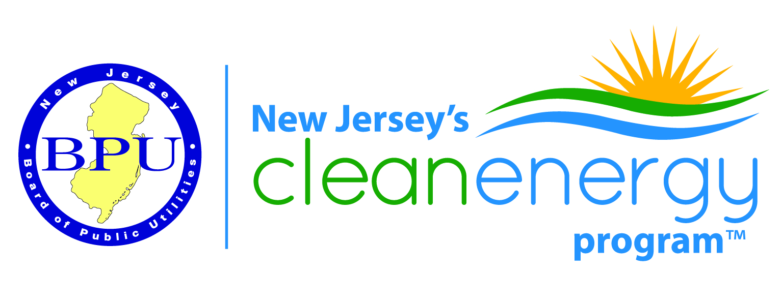
Energy Efficiency Committee Meeting
April 11, 2017
Location: New Jersey Board of Public Utilities, 44 S. Clinton Avenue, Trenton
Call in Number: 877-304-9323, Access Code: 6684102
(Please keep phones on mute and do not place call on hold)
Those on the phone may email their attendance to eeattendance@NJCleanEnergy.com

AGENDA
Introductions
Regulatory Updates (Marisa Slaten)
Presentation by Sustainable Jersey
Presentation by NJIT on the New Jersey Clean Energy Learning Center
Overview of Proposed Program Changes:
Long term as informed by the Draft Strategic Plan
Fiscal Year 2018
More detailed information on the new Multi-family Program
Other Business
Next Meeting Dates:
May 9 (tentative)
June 13

